CSA0619-Design and Analysis of Algorithm

16.Merge Sort:
Aim
To implement the Merge Sort algorithm, execute the program, and analyse its efficiency under best, average, and worst-case scenarios using asymptotic notations.
Problem Statement
Develop a program to implement the Merge Sort algorithm for sorting a list of integers in ascending order. Analyse the algorithm under best-case, average-case, and worst-case scenarios. Represent the time complexity using asymptotic notations and justify why Merge Sort is efficient for practical applications.

Algorithm:
- Start.
- Read the number of elements.
- Divide the array into two equal halves.
- Recursively apply Merge Sort to both halves.
- Merge the sorted halves into a single sorted array.
- Display the sorted array.
- Stop.

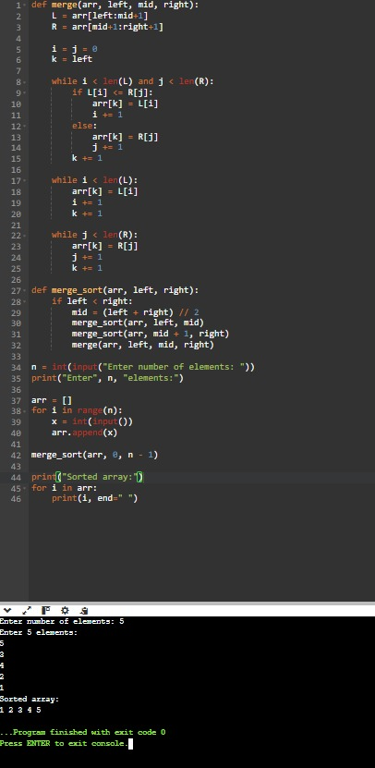
Source Code:

Report Analysis
Case | Time Complexity
Best | O(n log n)
Average | O(n log n)
Worst | O(n log n)

Space Complexity: O(n)
Asymptotic notation:
Best Case = Ω (n log n)
Average Case = Θ (n log n)
Worst Case = O (n log n)

Application: Natural Language Processing Engine
Aim
To solve the recurrence relation T(n)=T(n/2)+n using the substitution method and determine its asymptotic time complexity.

Problem Statement
An NLP (Natural Language Processing) engine processes text data using the recurrence relation T(n)=T(n/2) +n. Solve the recurrence using the substitution method, derive its complexity, analyses scalability as the text corpus size increases, and interpret the result using asymptotic notation.

Algorithm
- Start.
- Consider the recurrence relation T(n)=T(n/2) +n.
- Expand the recurrence repeatedly using substitution.
- Continue until the base case is reached.
- Identify the pattern.
- Derive the final complexity.
- Display the result.
- Stop.

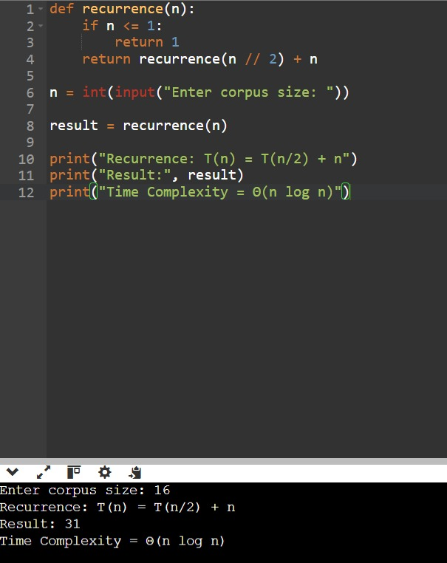
Source Code:

Step-by-Step Expansion:
Step 1
Expand once
T(n) = T(n/2) + n
Step 2
Substitute T(n/2)
T(n) = T(n/4) + n/2 + n

Step 3
Substitute again
T(n) = T(n/8) + n/4 + n/2 + n
Step 4
After k expansions
T(n) = T(n/2^k) + n(1 + 1/2 + 1/4 + ...)
Step 5
Stop when the subproblem size becomes 1
n/2^k = 1
2^k = n
k = log₂ n
Step 6
Substitute k
T(n) = T(1) + n log₂ n

Time Complexity | Θ (n log n)
Upper bound | O (n log n)
Lower bound | Ω (n log n)

